PROJECT ON STUDENT COUNSELLING SYSTEM

Abstract:
The project is mainly designed for distant people who are not able to avail any personal counselor, to provide them with a platform connecting with counselors around the globe. The Online Counseling System is developed to enhance counseling. The Online Counseling System is developing to enhance the counseling, which fully works as an online. This software will be great relief to the to counseling seekers for Reporting, Registration and searching the information about their career and overcome their problems.

Limitations of the Existing System:
The maintenance of various records and procedure of reporting are being done manually by the counseling department. This leads to many drawbacks some of which are:
• It is a time consuming process.
• Proper arrangements should be made before and after the counseling which is both money spending and time consuming.
• As the number of client's increases counseling process becomes more and more difficult.
• Not globally maintain the information
• Difficult to management the all types of information of the client.
• Further more, manual evaluation is prone to errors.

Proposed System:
In proposed system at first reduce the problem, which is faced in Existing System. So In the proposed system, Online Counseling System will provide the online facility for reporting/registration or access any type of information about the college/university and globally maintain all the information by the university and this project consist fallowing modules are

        - Client Module:
Provide the fallowing types of facilities using different options: -
          - Insert : This part allow any new client to create their account.
          - Delete : If any client want to delete his account.
          - Display : It will display all the client details.
          - Book Appointment: The client can make a appointment with any of the counselors.

2. Counselor Module:
Provide the fallowing types of facilities using different options:
          - Insert : This part allow any new user to register as a counselor.
          - Delete : If any counselor want to delete his account.
          - Display : It will display all the counselor details.

3. Inspiring case studies Module:
This module contains three sections displaying:
- blogs
- inspiring videos
- Fun facts and images

4. Admin Module :
The admin capable of the following actions:
          - Search: Search a counselor or a client.
          - Delete: It helps to delete a client or counselor.
          - Insert: Add new inspiring stories.

5. Log-in Module:
Lets the various users of the system to log-in.
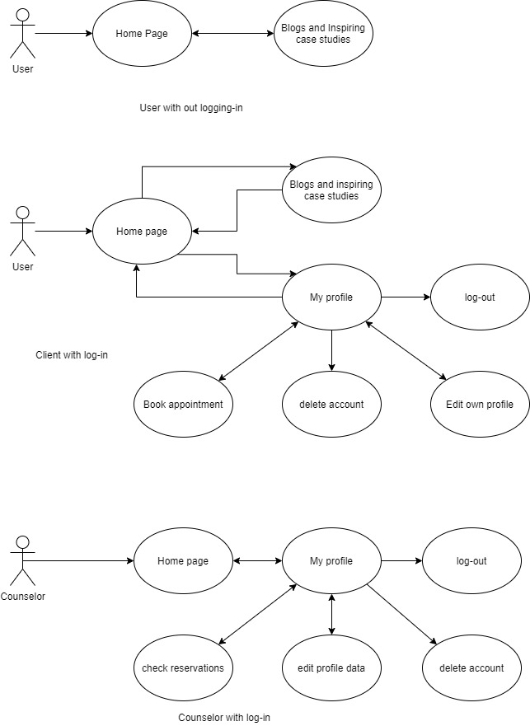
Flow Diagrams:

